**Project Title:** Urban Pixel Lab **Year:** 2025. 01 **Medium:** Generative Video / Code (Processing)

**Description** A computational study on order emerging from chaos. This project treats the brand identity not as a static image, but as a destination for drifting data. Through a sequence of six algorithmic ‘shots,’ the piece narrates the solidification of information into form, reflecting the invisible digital layers that coat our modern urban environments.

The generative system utilises custom algorithms to control over 1,800 autonomous pixel particles. These elements simulate data transmission, vertical scanning, and matrix-style convergence without the use of keyframes. The visual language draws inspiration from retro-futurism and media architecture, employing a high-contrast palette of neon green and deep charcoal to represent the pulse of a living digital city.

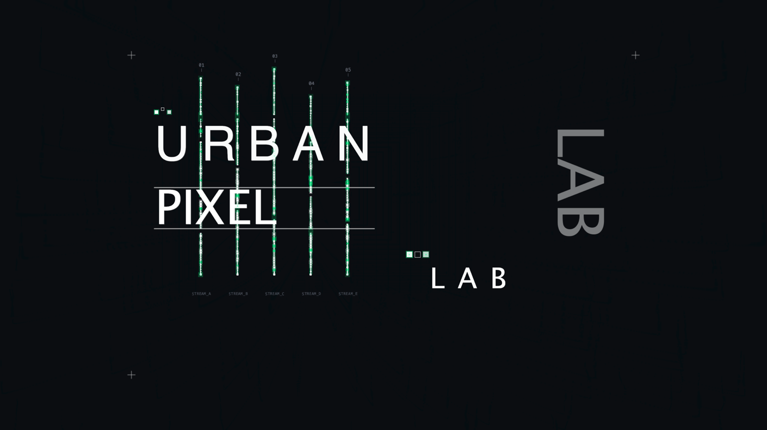

Video

  

Shot 1: The ‘Data Rain’ Shot 4: The Snap Shot 6: The Convergence

**Technical Stack**

* **Language:** Processing (Java)
* **Core Concepts:** Object-Oriented Programming (OOP), Particle Systems, Noise Functions, Easing Algorithms.
* **Implementation:** Custom classes for DataStreams and PixelBlocks featuring autonomous behaviours (drifting, pulsing, aligning).